Aricka Wilde, Bridget Kreis, Savannah Bassett
Brook Weenig, Whitney Wilcox
October 10, 2014
Comms 421:003

Mock press conference

Outline

· The top priority in this frenzy is to ensure that we protect the well being of the patients that we have in the hospital and also hold up all HIPPA privacy laws. Thus, we will broadcast to our staff, the media, physicians and the administration to uphold and protect the patient’s privacy.
· We would then focus on internal communications, scripts for operators, security, staff and hospital boards, along with creating a social media response online. We would provide hourly updates to the media of status of the patients within the hospital and also what we are doing to ensure their quick recovery. Communication with the victims families and keeping them updated will also be top priority.
· Within the first hour of the patients being admitted to the hospital we would have a media debriefing to ensure the media we are taking proper precautions and offer up our condolences about the tragedy.
· Hourly updates of what the hospital is doing online, including paging the media whenever we have media updates or experts who come to discuss the matter.
· Security is debriefed on what to say to media. Media or anyone will not be admitted into the hospital unless they know the specific name of the patient or have direct relationship with injured patient. .
· We would respond quickly to the media, and provide timely, accurate information to all of the following publics: affected families, staff, physicians and community.
· Media statements and briefs sent daily until the last patient is discharged from hospital. These statements would include: the general condition of the patients—but not their names, family support line and contact information such as a media pager. We would also keep the media updated on when the latest patient update would be.
· To do this type of updating we would use the real-time patient flow technology—used by other hospitals in crisis situations—to keep relatives, media and the officials updated on the status of the patients.
· We would act as mediators between the media and the affected families, including arranging media interview opportunities with the families.
· We would arrange various interviews with physicians and specialists in the trauma section and ER portions of the hospitals, so that the media could have access to some type of interview.
· On social media and media briefings we will emphasize our condolences, the quick response of the emergency squad and assurance that the hospital is doing the best they can to ensure all are cared for.
· Throughout the night we will constantly be updating our crisis plan with new information that comes available.

Strategy brief for press release

Key public (audience): Adult news readers/viewers, specifically in the Pittsburgh area. The typical reader/viewer is male, Caucasian, 35 and older, middle to upper income. 51 percent of Pittsburgh adults claim they read the newspaper (http://www.post-gazette.com/local/city/2013/06/13/Pittsburgh-is-tops-in-newspaper-readership/stories/201306130261).

Secondary publics (audiences), if any: Hospital donors and board.

Action desired from public(s): Primarily, to avoid widespread panic by keeping the community informed of what happened and what is being done. Another desired action is to gain support from the community, either verbally or through donations to the cause.

How that action ties to the key public’s self-interest: The public wants to know that they are safe and that their families are safe. They want to know what has happened and what steps the hospital is taking to treat the victims and support the community. They also want to know how they can help.

News hook: Impact, community, proximity (local community), human interest, provides conflict (related stories about gun laws, shootings), kairos--shootings in community that occurred last night.

Proposed headline: Pittsburgh General Hospital treats victims of theatre shooting

Proposed lead: As the community grieves in the aftermath of the “Darkness Gathers” shooting, Pittsburgh General Hospital is doing all possible to treat 16 of the surviving victims.

Primary message: We support the victims and their families.

Secondary messages:
- 18 victims, two died within the hour
- Families have been contacted
- Privacy laws

Primary message: We were prepared for an crisis like this to happen

Secondary messages:
- Crisis management plan in action
- Biannual drills

Primary message: We need community support.

Secondary messages:
- Number to call for support, trauma specialists, etc.
- Donate to a victims fund

Website: http://www.pgh.org/

Proposed photos (if any): Photo of crime scene, hospital staffers caring for a patient, hospital press conference, photo of hospital and doctors, photo of the scene of the crime.

Method and timing of distribution (e-mail, fax, etc.): Released in press conference, Monday, October 13, 2014.

Specific media to receive release: Local news and media outlets, as well as national.

Follow-up with media (if any): Continued press conferences as we know more and as patient status changes

Sources:
- http://www.cnn.com/2012/07/20/health/colorado-shooting-emergency-response/
- (http://www.post-gazette.com/local/city/2013/06/13/Pittsburgh-is-tops-in-newspaper-readership/stories/201306130261)

Bridget Kreis FOR IMMEDIATE RELEASE: 10/13/14
Pittsburgh General Hospital
412-653-8997
bridgetkreis@pgh.org

Pittsburgh General Hospital treats victims of theatre shooting
Hospital cares for victims of shooting at local theatre

Pittsburgh, Oct. 13, 2014— As the community grieves in the aftermath of the “Darkness Gathers” shooting, Pittsburgh General Hospital is doing all possible to treat 16 surviving victims.

After the shooting, 18 patients were immediately brought to the hospital. Two died within the hour, six are currently in intensive care, and the other 10 are being treated for varying injuries. Hospital staff members have contacted the families of the victims but at this time, out of respect for the privacy of patients and their families, the hospital is unable to release patient information.

“Our condolences go out to the victims and their families. This nightmare is a tragedy beyond words and one you could never anticipate. Our hearts are mourning along with all of you as we all try to cope with this reality, but we must respect the privacy of our patients and their families,” said Brooke Weenig, head orthopedic surgeon at Pittsburgh General Hospital.

Hospital staff responded promptly and efficiently to the incident. Pittsburgh General Hospital holds biannual drills, during which workers practice emergency-type situations. Included in the practices are retrieving and treating victims in less than one hour, communicating with outside parties, calling in extra personnel—including trauma specialists—and contacting surrounding hospitals.

"All area hospitals that received victims are providing outstanding care,” said Aricka Wilde, CEO of Pittsburgh General Hospital. “Without having much warning, many are dedicated to taking care of the rush of victims. Added security units have been brought to each hospital, and staff members are working around the clock.”

The hospital will not be charging for their services to victims and asks community members to stand together in this trying time. If you would like to contribute monetarily to a fund established for victims please contact hospital staff at 412-422-4357 or www.pgh.org.

Future press conferences will be held as more information is released.

###

About Pittsburgh General Hospital

We are a state-of-the-art hospital committed to providing the best healthcare to our community. We have been providing excellent service for over 50 years. Our staff consists of trained medical professionals versed in lifesaving medical procedures and prepared to handle emergency situations.

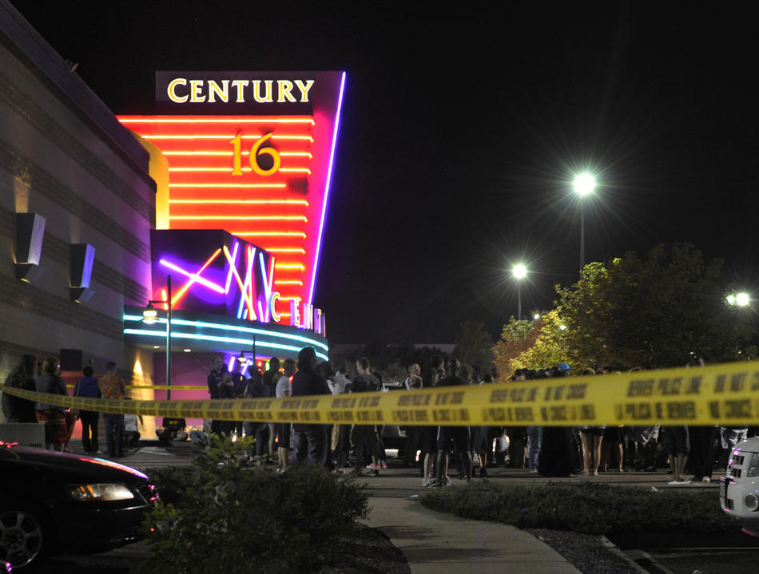Pittsburgh General Hospital cares for 18 victims of “Darkness Gathers” shooting, Photo by Whitney Laycock

Strategy brief--press conference

Key public (brief profile including motivating self-interests): Local community of Pittsburgh
Secondary publics, if any: Hospital Donors and board members
Action desired from public(s): Support the families affected from the tragedy through community service; also a main desired action would be to be calm and confident that the hospital is doing all possible to care for the victims.
Speaker: Physician supervising care of patients, nursing supervisor, hospital administrator, public relations specialists
Venue: The board room in the hospital
Length: 10-15 minutes
Audience: Media-news reporters, journalists, etc.
Overriding message (should tie to overall big idea): We offer our condolences and are doing everything possible to care for the patients affected by this tragedy and ask for the support of the community.
Opening attention-getting device (humor, story, statistics, etc.): Condolences to the family
1. Primary message: We offer condolences to the victims and their families. This is our home, and we are doing everything we can to protect it.

Secondary:
- Families have been contacted and are being updated by our staff
- Two died within the first hour, despite our best efforts
- Community and hospital members responded within one hour of the shooting

2. Primary message: Our hospital was prepared to treat the victims of the tragedy and to provide the families with up-to-date information.
Secondary:
- The hospital will not charge a co-pay to affected families
- Our hospital holds biannual drills, during which workers practice emergency-type situations
- Included in the practices are retrieving and treating victims in less than one hour, communicating with outside parties, calling in extra personnel—including trauma specialists—and contacting surrounding hospitals
- Real-time patient flow technology allows staff, relatives, media and officials to see the status of the affected patients

3. Primary message: We have systems in place to help bring healing to victims and their families, as well as the community.
Secondary:
- An onsite psychologist is provided for the families and will be conducting seminars on effective ways to overcome trauma
- We are committed to offer guidance and support to the victims, their families and all those who have been effected from this tragedy
- An entire nursing staff is devoted to the 24 hour care of the victims
- There were 18 patients admitted. Two patients died within the hour upon arriving at the hospital. Six patients are still in intensive care in critical condition. The other 10 have been admitted to the hospital for varying degrees of care but are not in life threatening situations

Third-party opinion leaders and how they will be used (testimonials, quotes, etc.): Staff, the mayor, the trauma specialist, the psychologist.

Visuals and/or video to be used, if any: None
Conclusion: We were prepared to handle the incident and are dedicated to helping victims, their families and the community in this time of healing.
Timeline/deadline: Within the first hour of the patients being admitted, morning after, updates every hour.

QUESTIONS FOR THE PRESS CONFERENCE

Questions for doctor:

How are the families of the victims doing? They have all been contacted and the majority are being housed and cared for by the hospital at this time.
Can you give us the timeline of the two victims that died at the hospital? After arriving at the hospital, the two with multiple gun shot wounds were admitted and taken into immediate surgery, by the time the surgery was being performed, they had lost their life. Our staff did everything that they possibly could, but the injuries were too severe.
Do the families of the fatally wounded victims know of their deaths? Yes, they have all been contacted.
What more could you have done to save the two fatally wounded victims? Our hospital was prepared for the event, but because of the severity of the given wounds, we were unable to perform surgery that was effective and quick enough to heal the various wounds on the bodies.
How old is the youngest victim? Six years old.
What is being done to treat the victims? Because of the nature of gunshot wounds, it has been necessary that many of the victims have surgery in order to care for their needs. We are treating each individual with the best care as we have done in the past and have brought in reinforcements to ensure minimal mistakes are made.
Can you disclose the victims’ names? No, I am not at liberty to disclose the names of the victims.
Can you tell us more about the victims in critical condition? We cannot at this time offer more details about the patients to protect their privacy and adhere to the HIPAA laws.
How many other doctors or hospitals are involved? 3 other hospitals are involved. I can’t release the information of how many doctors, as many have been in and out of the rooms throughout the night.
How many gunshot wounds were found on the victims? We cannot at this time offer more details about the patients to protect their privacy and adhere to the HIPAA laws.
CURVEBALL- It is reported that you are also treating the shooter, what is your response to that claim? We are committed to treating all of our patients equally and cannot release any information on whether the shooter is being treated in our hospital, to protect both his safety and privacy. Our job is not a political position, our job is to treat people who are injured.

Questions for nursing supervisor:
How many nurses are treating the victims on your staff? We have a total of 20 nurses working around the clock. Each are given specific shifts to ensure that no mistakes are made.
Are the nurses working 24 hours and able to take breaks? All of our nurses are able to take breaks and rest when they are tired. We want our nurses and staff to be alert and working to their best abilities. Obviously because of the extent of the situation, nurses and staff will have to work longer shifts, but they are given the rest they need.
Have your nurses seen anything like this before? Our staff has been prepared for crisis situations and deals with trauma situations on a daily basis. We were prepared for something like this to happen, although we are extremely sadden by the crisis itself.
Can you tell us how your staff was prepared to treat the victims? We have had an emergency preparedness plan in place for a long time and have trained our staff and trauma team for these kinds of situations.
Did the increase of patients affect the other patients in the hospital? No, we are well-staffed and have had support from our physicians and nursing staff. The response to this crisis has been overwhelming from the community as many were ready and willing to support and help these victims and their families.
How can the local community get involved with helping the victims? The local community can donate to a fund that the hospital has in order to help these families. More than anything in this time of need would be support, but also respect for the patients’ privacy.

Questions for hospital administrator:

How are you communicating/helping the families of the victims? We have real-time technology that updates the families every 10 minutes and allows them to see the status of the victims. We have talked to each affected family individually and have ensured that they are aware of what precautions we are taking and how their loved-one is responding to the surgeries and treatments they have received.
Does the hospital have enough space/rooms to treat the victims? Yes, we recently expanded our hospital by 250 beds.
Is your hospital compensating the victim’s families, in terms of medical bills? We will be funding the medical bills for the victims and their families. We are raising money for these bills through community donations and private donations.
How has your security responded to the onslaught of media and press? Our security has been debriefed to only allow family members into the hospital to see the affected patients. Security levels have been increased to ensure the privacy of the patients and their families as this is a high-profile case.
How are you coordinating with other hospitals to cover the individual needs of the victims? Within the hour of the shooting, we had coordinated with the three surrounding hospitals in order to ensure that each patient had access to high-quality care and that there was enough surgeons to perform the surgeries. We also call them every half hour to ensure that they aren’t in need of reinforcements. This is a team effort, and we are all pulling together to heal the affected families and victims.
How is your hospital going to move forward in treating the victims? We will providing the best care for our victims as we possibly can, up until the day they are released. We will also provide physical therapy and treatment to victims and their families throughout the following months, in order to aid in their recovery.

Questions for the PR representative:

How will this crisis affect the reputation of the hospital? The hospital will remain to have a good reputation in the Pittsburgh community because of its focus on quality health care.

What has been done to communicate today’s events to the public? We have kept the lines of communication open with the local community as well as the national community via social media. The hospital has a constant stream of updates on facebook, twitter and instagram.
How is the hospital handling internal communication during this crisis? Our employees and patients have always been our top priority. We are keeping all of our employees informed on the status of the patients as well as other internal affairs of the hospital. Communication is key in maintaining the success of the hospital.

What is the next step for hospitals around the community? Each of us is committed to the quick recovery of the affected victims and are committed to seeing each of them reach full recovery. The next step is to continue forward offering hope to the community in this time of healing.

How will your plans to handle such a crisis change in the future? We will continue to hold courses such as our biannual drills, during which workers practice emergency-type situations. Included in the practices are retrieving and treating victims in less than one hour, communicating with outside parties, calling in extra personnel—including trauma specialists—and contacting surrounding hospitals. We know that being prepared as a hospital is critical for future success.

Plan of action to answer questions our team may not have foreseen:

For the questions that our team may have foreseen we will direct those questions back to our main, core messages. Which includes: offering condolences, asking for support from the community, ensuring that were prepared for the event and our dedication to helping heal the patients and respecting their privacy in this time of tragedy.

Media statement

Good morning,

A horrible tragedy has befallen our community and our thoughts and prayers go out to the victims and their families during this time. We grieve for all the people in our community affected and hope to offer as much support and care as we possibly can.

On behalf of our community, I would like to personally thank the many members of our trauma staff and those in our community who responded quickly to provide care and support for the victims and their families. Your devotion to this hospital and our community is what we are all about.

At this time we cannot release the names of any victims for their protection and privacy. However we can say we have received 18 patients ranging from 16 to 31 years old whose injuries vary in range and severity. These patients have our attention and care, and will continue to receive the best medical attention we can provide until they are released. Despite our staff’s best efforts, two of the victims died within the hour of being admitted. We grieve this loss and the families of the all victims have been contacted, but we ask that you respect their privacy at this time.

In order to provide the best care for the affected patients, we are expending all of our resources for patients, and will provide hourly updates on their status. Our staff was well trained and prepared for this type of crisis. We have our clinical psychologist on hand to provide care and counseling for the victims and their families, and will be conducting seminars on appropriate ways to overcome trauma in our community.

At this time we cannot offer any more details about the shooting or the victims because it is an ongoing police investigation, and we will not be taking any questions of this nature.

(Questions from the press)

