Whitney Laycock FOR RELEASE: 10/01/14
The Coca-Cola Company
404-676-1533
wlaycock@coca-cola.com

Coca-Cola offers families a chance to reconnect with their roots
In honor of Hispanic Heritage Month, Coca-Cola is sponsoring a contest for families to win a free vacation

Houston, Sept. 28, 2014 – The Coca-Cola Company wants to take families on vacation—for free. In honor of Hispanic Heritage Month, Coca-Cola is offering a contest to give families a chance to remember their culture and reconnect with their roots.

“Every family has a unique story and proud heritage,” said Alba Adamo, vice president of multicultural marketing at The Coca-Cola North America Group. “These vacations will make it possible for families to come together in spite of distance and make new memories while celebrating culture.”

The contest is known as “Momentos Coke.” Families can enter the sweepstakes once a day from now until the end of October. Entering is easy—individuals can visit “My Coke Rewards” (http://www.mycokerewards.com/content/hhm.html) and either upload a product code or tweet a family photo using #momentoscoke.

The Coca-Cola Company has partnered with Delta Air Lines, Inc. in offering nine vacations that include $2,000 in travel vouchers and $1,000 in gift cards. However, with over 300 chances to win something, families stand a good chance at being recognized.

This is not Coca-Cola’s first outreach effort. A longtime supporter of education, the company has donated millions in scholarships across the nation. This year, Coca-Cola’s Hispanic Heritage Month scholarship program will award over $200,000 in scholarships to Latino students.

“Coca-Cola has always been family-oriented,” said Fidel Vergara, group director of Hispanic marketing at The Coca-Cola Company. “This month is about hope. We want to further all aspirations, whether in the form of obtaining an education or taking a vacation and making memories.”

To learn more about the contest or Hispanic Heritage Month, visit The Coca-Cola website (http://us.coca-cola.com/home/) or Market Watch (http://www.marketwatch.com/story/coca-cola-honors-hispanic-heritage-by-celebrating-family-moments-2014-08-29).

About The Coca-Cola Company

The Coca-Cola Company is the world’s largest beverage company. For over 200 years, the company has been serving individuals. Today, roughly 1.9 billion Coca-Cola products are consumed each day. The Coca-Cola Company is devoted to supporting the community through healthy living initiatives, environmentally safe practices and social outreach programs.

###

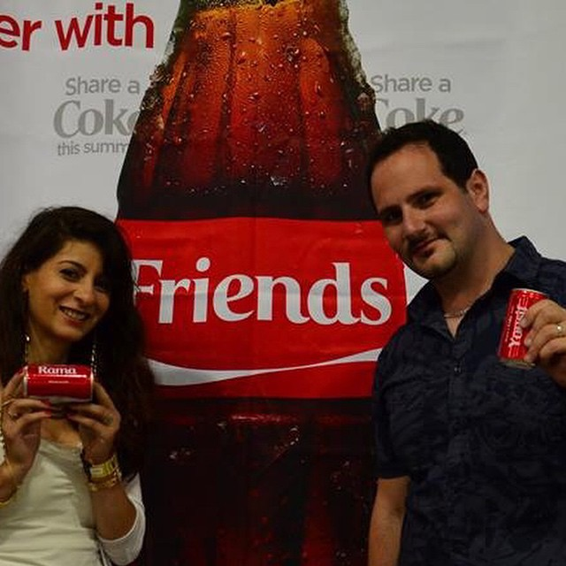

Don Chamelo and a friend enter for a chance to win a free trip sponsored by The Coca-Cola Company.

Media Pitch to Rich Sanches, Fox News Latino

Hi Rick,
We are contacting you because of your article, “Cubans, an Immigrant Success Model.” We appreciate your writing style and positive mention of The Coca-Cola Company.
We are sponsoring a chance for families to win a free vacation in honor of Hispanic Heritage Month. There are over 300 chances to win something, and entering is as easy as tweeting a family photo and uploading it to Coca-Cola’s website. Because of your previous experience writing about Coca-Cola and your work with the Latino community, we would like to send you our press release.
Please let me know if you are interested and we will send it immediately. Thank you, Rick.
All the best,
Whitney
wlaycock@coca-cola.com

Whitney Wilcox Laycock
September 28, 2014
Comms 421:003

Strategy Brief: News Release
*Note: I was unable to find the one on Learning Suite. I copied this from A Matrix Approach to Public Relations and Marketing.
Key public (audience): Families and individuals, specifically Hispanic Americans.
Secondary publics (audiences), if any: Reporters and editors—those we want to reach in order to communicate our news release.
Action desired from public(s): We want individuals to sign up for the “My Coke Rewards” program, buy more Coca-Cola product, or post a picture of his or her family with a Coca-Cola product. We want reporters and newspapers to pick up on the story and feature it in order to reach more people.
How that action ties to the key public’s self-interest: The public has an opportunity to win a free trip.
News hook: Win a free trip for your family.
Proposed headline: Coca-Cola honors Hispanic Heritage Month by offering families a way to reconnect with their roots
Proposed lead: In honor of Hispanic Heritage Month, Coca-Cola is offering families a chance to reconnect with their roots and take a free trip to a destination of their choosing.
Primary message: Coca-Cola is offering a chance to reconnect with your roots and remember your unique heritage.
Secondary messages:
- Coca-Cola is celebrating your family. Upload a picture at #momentoscoke
- An uploaded picture
- Coca-Cola is celebrating Hispanic Heritage Month and providing a way to visit your family
Primary message: It is easy to enter and you can enter more than once.
Secondary messages:
- Over 300 chances to win
- Can enter up to 320 times
- The contest ends October 31, 2014
Primary message: Coca-Cola is a socially responsible company. It invests thousands in developing communities.
Secondary messages:
- Coca-Cola gave $200,000 in scholarships to the Hispanic community in 2013, and has donated over $400 million since 1975.
- Coca-Cola supports social outreach programs
Proposed photos (if any): One uploaded for the contest, preferably of a Hispanic family.
Method and timing of distribution (e-mail, fax, etc.): Email sent Monday, September 29, 2014.
Specific media to receive release: Fox News Latino
Follow-up with media (if any): An email sent on Friday, October 3, 2014.
Timeline/deadline: The contest runs from August 29, 2014 to October 31, 2014. We want our announcement to come out Wednesday, October 1, 2014.
SEO keywords:
- Hispanic
- Hispanic Heritage Month
- Momentos
- Roots, heritage
- Family
- Free
- Trip
- Contest
- Coca-Cola products: including Diet Coke, Fanta, Sprite, and Coca-Cola Zero
- Scholarship
Sources:
- http://www.mycokerewards.com/content/hhm.html
- http://www.coca-colacompany.com/press-center/press-releases/the-coca-cola-company-and-the-hispanic-scholarship-fund-share-possibilities-through-scholarship-program-for-hispanic-students
- http://us.coca-cola.com/home/
- http://www.marketwatch.com/story/coca-cola-honors-hispanic-heritage-by-celebrating-family-moments-2014-08-29

